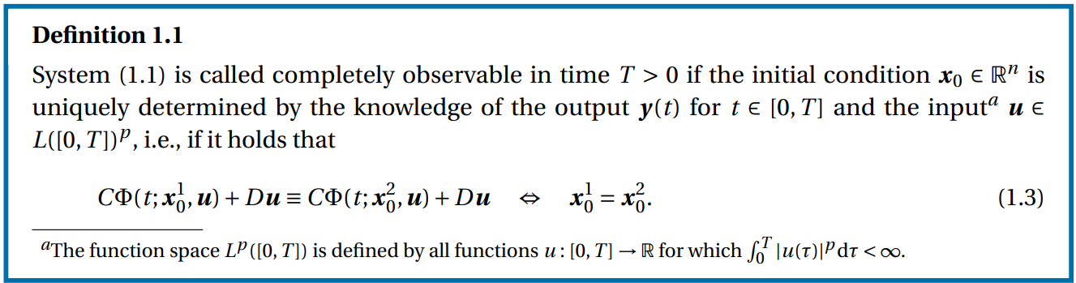

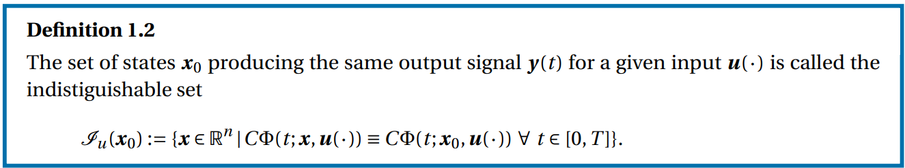

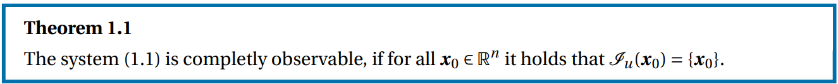

In brief, a system is completely observable if for each state x, its indistinguishable set is itself.

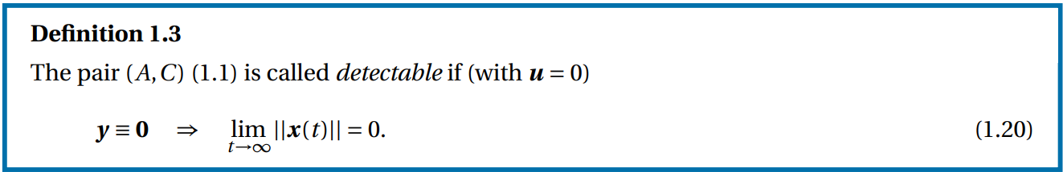

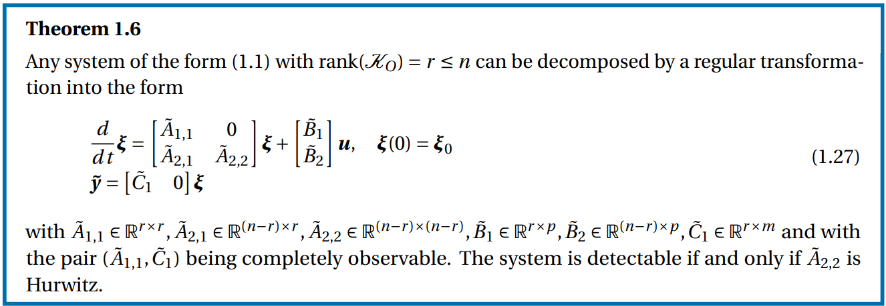

In brief, a system is detectable iif the matrix for its unobservable subspace is Hurwitz.